**PROJECT REPORT TEMPLATE**

**1 INTRODUCTION**

1. **OVERVIEW**

A logo is a symbol or mark used to represent your brand. You can think of it as your signature. Above all, the primary role of a logo is brand recognition. A good logo design will help your customers instantly recognise your business. Therefore your logo should be distinctive, clear and memorable.With logo design, you have a visual communication tool to help you get your message across to the audience. Logos are composed of text, color, shape, and illustrations. It serves as a self-explanatory image that people can use to connect with your brand.

1. **PURPOSE**

Although a logos primary purpose is to identity, they can also be leveraged to communicate important brand messages and values. Just make sure to keep it simple… ideally stick to just the one key idea

The first and most important role a logo plays in your company’s life is identification. They help your audience recognize, identify, and select your business before anyone else’s. At the end of the day, all the other stuff behind a logo is just white noise in comparison to this one role.

**PROBLEM DEFENITION AND DESIGN THINKING**

1. **EMPATHY MAP**

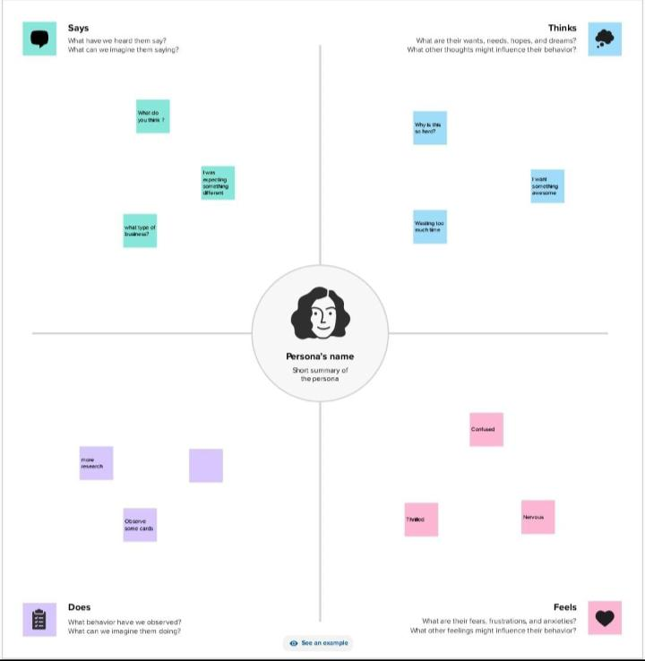

1. **BRAINSTROMING**

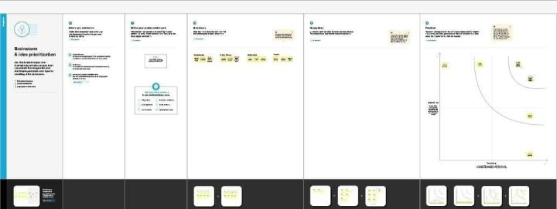

1. **LOGO DESIGN**

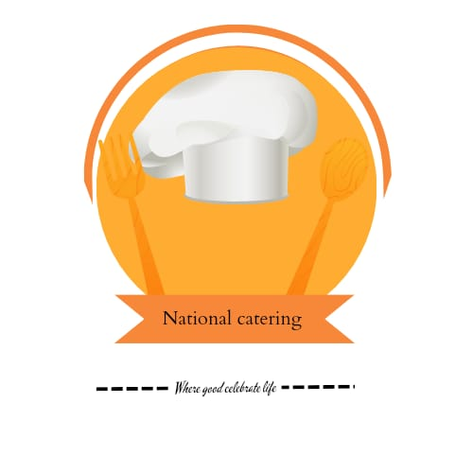

**ADVANTAGES**

1.Anyone can be a designer using Canva.

2. Canva is very simple to use and user friendly.

3.provides templates of the correct sizing for other online platform

4.Grabs the Attention of Customers.

5.Building Block for the Brand Identity.

**DISADVANTAGE**

1. Limitation of number of templates
2. Export settings are limited
3. Cannot download the “raw” file to your computer.
4. Create Confusion amongst Customers.
5. Less Professional.

**APPLICATION**

Canva makes designing beautiful creative assets easy for everyone. From social media images, videos and gifs to posters, websites, booklets, multimedia presentations, and heaps more, Canva is an invaluable tool for helping you level up your design skills, even if you’re just getting started.

**CONCLUSION**

Canva is a user-friendly platform that allows even non-designers to create graphics easily. With its drag and drop interface, you can customize premade logo templates, or start from scratch and create your own unique logo design.